Chapter 10, Solution 15.

We apply nodal analysis to the circuit shown below.
j 
4 
2 I
5 A
2 
+
−
-j20 V
-j2 
V₁

V₂

I
At node 1,
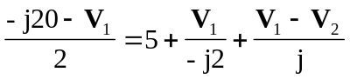
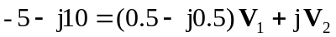 (1)

At node 2,
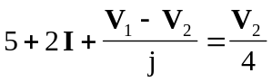,
where 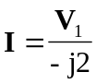
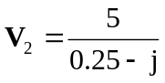V₁ (2)

Substituting (2) into (1),
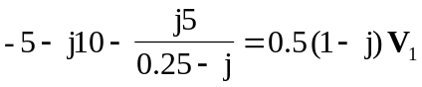
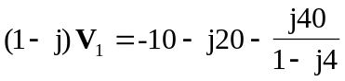
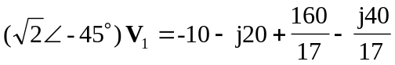
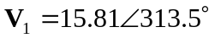

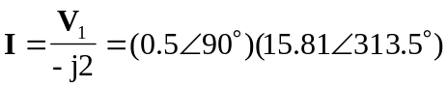

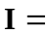 7.90643.49 A

